Koby Miller

Lab 4

2/16/2020

Pre-lab4 Report

clk_div waveforms

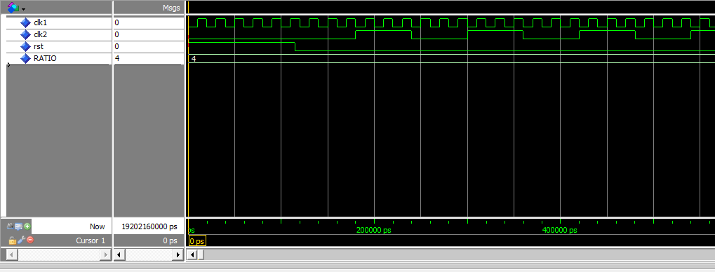ratio of 4

ratio of 2

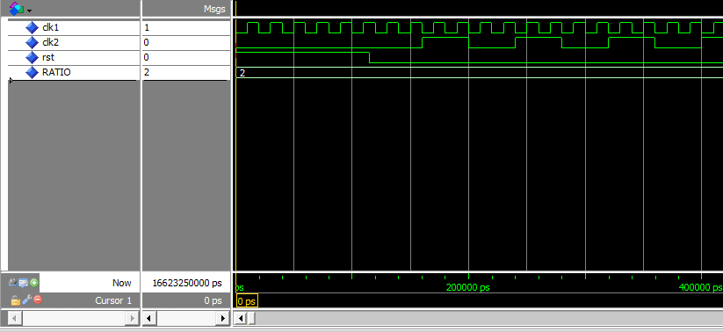

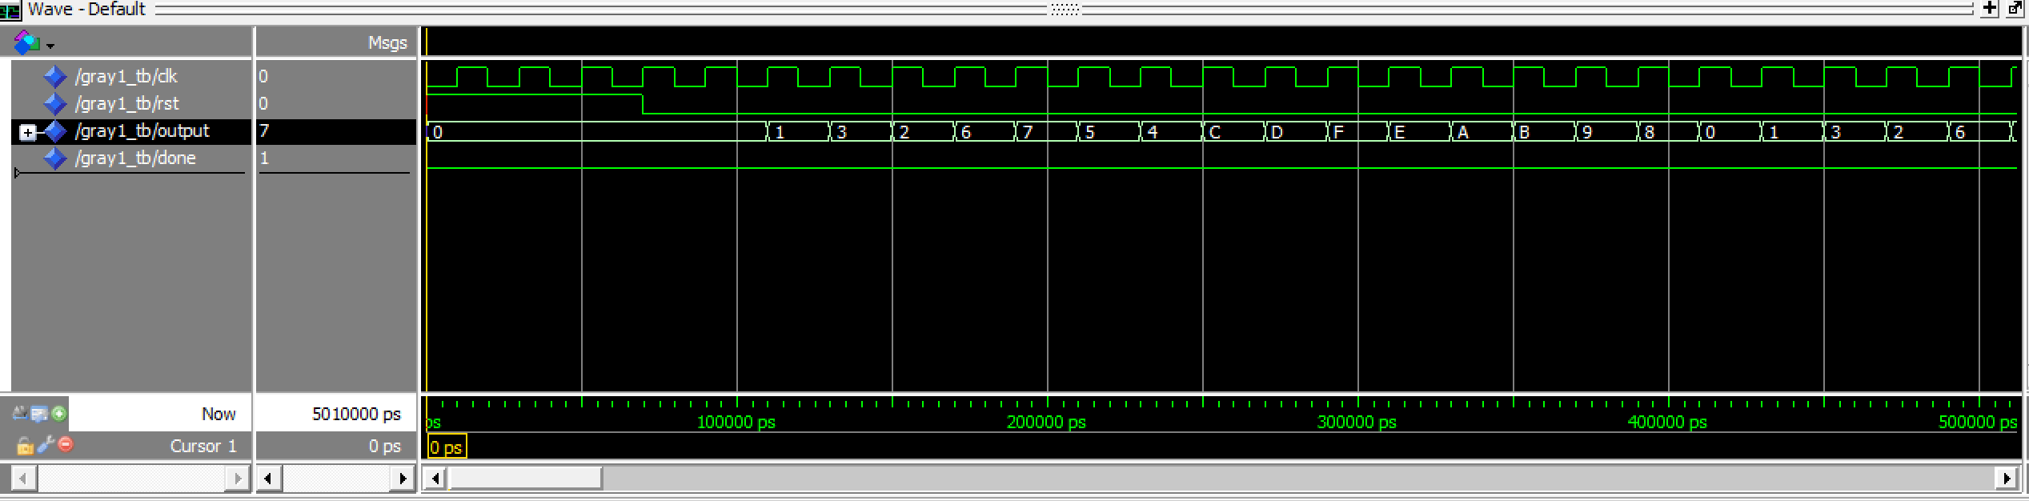Grey1 waveform.

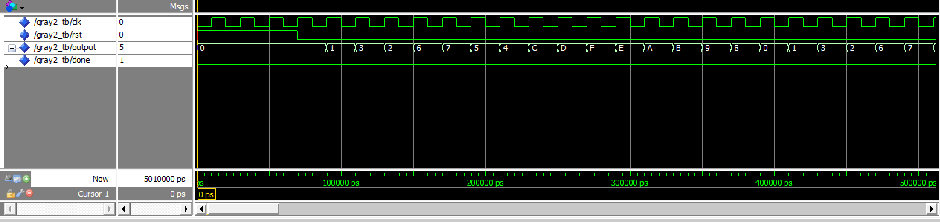Grey2 waveform.

Counter:

This first picture shows the reset for the counter working, it counting up, and it wrapping back around.

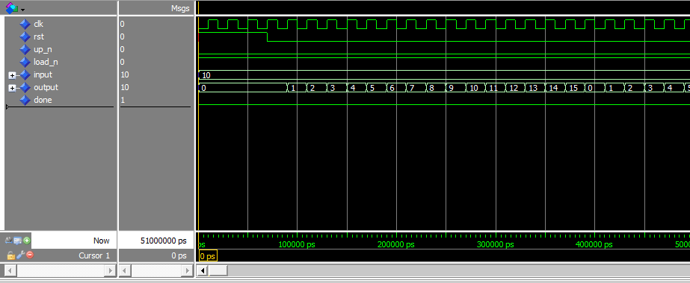

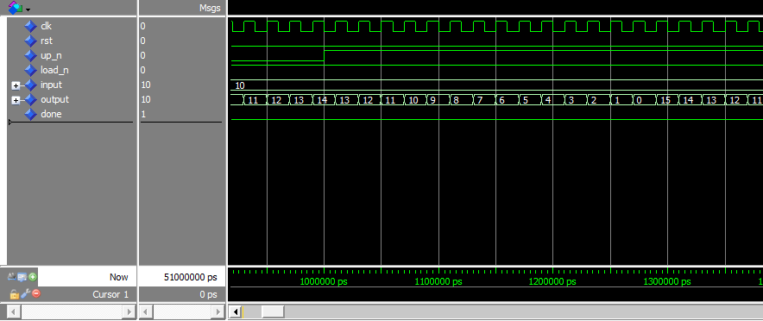This second picture shows that it correctly counts down.

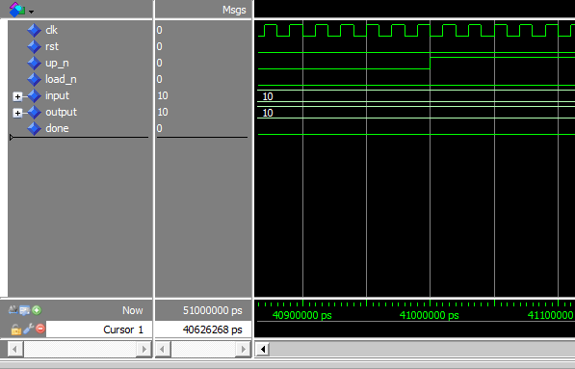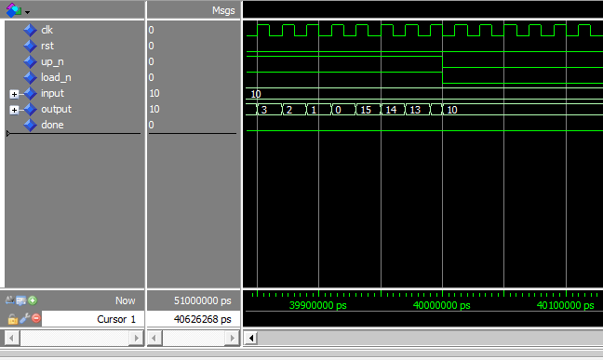Lastly, these two pictures show the load working and having a higher priority than the up counter.

Top level description:

The top level starts out by declaring the different components that were made throughout the lab (decoder7seg, clk_gen, gray2, and counter). It then declares some constants and signals that will help with connecting our components in the final section. The final section creates our components and connects them together.

Overall, it maps the our “counting button” and rst to our buttons, it maps the up_n, load_n, and input to our switches, then maps the output of the grey2 to one of the 7 segment decoders and the output of the counter to another 7 segment decoder.